A

SEMINAR REPORT ON

“Smart Device to Enhance Safety of the Vehicle”

SUBMITTED TO THE SAVITRIBAI PHULE PUNE UNIVERSITY, PUNE

IN THE PARTIAL FULFILLMENT FOR THE AWARD OF THE DEGREE

OF

BACHELOR OF ENGINEERING

IN

COMPUTER ENGINEERING

BY

THOPATE RUTURAJ SATISH (CO3073)

Under the Guidance of: -

Prof. Rutika Shah



DEPARTMENT OF COMPUTER ENGINEERING

KJ’S EDUCATIONAL INSTITUTE

TRINITY COLLEGE OF ENGINEERING

AND RESEARCH

Academic Year: 2023-2024



# CERTIFICATE

This is to certify that the Seminar Report entitled

“Smart Device to Enhance Safety of the Vehicle”

Submitted by

Ruturaj Satish Thopate (CO3073) Is a record of bonafide work carried out by her/him under supervision and guidance of Prof. Rutika Shah in partial fulfilment of the requirement for TE (Computer Engineering) 2019 course of Savitribai Phule Pune University, Pune in the academic year 2023-2024.

Prof.Sai Takawale Prof.:Rutika Shah Prof. Geetika Narang

Internal guide STC Co-Ordinator Head of Department

Department of Computer

Date:

Place:

**SAVITRIBAI PHULE PUNEUNIVERSITY**

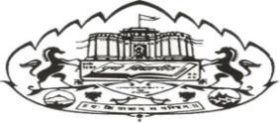

*An*

*Approval Sheet for Seminar Topic*

|  |  |  |
| --- | --- | --- |
| **Sr.No.** | **Seminar Topic Name** | **Remark(Approved/Not Approved)** |
| 1. | Device to Enhance Safety of the Vehicle Smart |  |

Submitted by

**Mr. Ruturaj Satish Thopate**

Under the Guidance of

**Prof. Sai Takawale**

# ACKNOWLEDGEMENT

To put an effort like this requires the determination and help of many people around me and I would not be doing justice to their efforts by not mentioning each helping hand in person. I feel privileged to acknowledge with deep sense of gratitude to my guide Prof.Rutika Shah for this valuable suggestion and guidance throughout my course of my studies and help render to me for the completion of report. I express my heart full gratitude to Dr. Geetika Narang Head of Computer Engineering Department other staff members of Computer engineering department for their kind Co-operation.

Last but not the least I would like to thank my parents and my friends. It would have not been possible to complete the report without their moral support, valuable comments and suggestions which motivated me towards work.

(Students Name & Signature)

Ruturaj S Thopate

# ABSTRACT

The main motto of the project is to use the wireless technology effectively for the automotive environments by causation SMS just in case of felony intimation. The most scope of this project is to prevent the engine of an automobile mechanically. This will be done whenever someone making an attempt to steal the vehicle, at that point sends an interrupt to a programmable microcontroller that stores owner's range upon a miss necessitate the primary time. once somebody tries to steal the vehicle then microcontroller gets an interrupt and send the SMS, the owner receives a SMS that his vehicle is being purloined then the owner sends back the permission to 'STOP', whereas the vehicle are going to be stopped. The management instruction is given to the microcontroller through interface, the output from that activates a relay driver to trip the relay that disconnects the ignition of the auto leading to stopping the vehicle.

# Index

|  |  |  |
| --- | --- | --- |
| Sr. no | Name of Topic | Page No |
| 1 | Introduction  1.1-Overview  1.2-Scope of Objective  1.3-Purpose | 6-7 |
| 2 | Literature Survey  2.1-Existing system  2.2-Limitations of existing system  2.3-Proposed system | 8-12 |
| 3 | Requirement Analysis  3.1-Software specification  3.2-Hardware specification | 13 |
| 4 | Project Description  4.1-Problem Definition  4.2-Project Overview  4.3-Advantage | 14 |
| 5 | Module Description | 15 |
| 6 | Conclusion | 16 |
| 7 | Reference | 17 |

# INTRODUCTION

This Project presents associate degree automotive localization system exploitation GPS services. The system permits localization of the car and sending the Position to the owner on his /her mobile as a brief message (SMS) at his/her request. just in case of car stealing things, the owner will recognize the vehicle’s current location and supported that he/she will stop the vehicle by causation a predefined SMS message to the current system. once receiving SMS message from owner this technique mechanically stops the ignition thence the vehicle won't perform from now on. From the Figure1 we will perceive the most method of the system.

What is internet of things?

The Internet of Things (IOT) is that the network of physical objects or “things” embedded with physical science, software, sensors, and network property, that permits these objects to gather and exchange knowledge. IOT permits objects to be detected and controlled remotely across existing network infrastructure, making opportunities for a lot of direct integration between the physical world and computer-based systems, and leading to improved potency, accuracy and economic profit.

## GPS technology

The Global Positioning System (GPS) could be a system supported world navigation satellite system (GNSS) that offer reliable location and time info in the least time in any whether or not condition on earth. it's composed of a network of twenty four satellites of the u. s. that are antecedently employed in military services, and later allowed for business use. The satellite emits radio radiation of short pulses to GPS receiver sporadically. A GPS receiver receives the signal from a minimum of four satellites to reason its three-dimension position that's latitude, meridian and altitude. Therefore, GPS could be a key technology for locating a tool location.

# SCOPE OF OBJECTIVE

The main scope of this project is to prevent the engine of associate degree automobile mechanically. this may be done whenever an individual making an attempt to steal the vehicle, at that point sends associate degree interrupt to a programmable microcontroller that stores owner's variety upon a text message for the primary time.

# PURPOSE

The purpose of the implementation method is style {/to style} and make (or fabricate) a system component conformist thereto element's design properties and/or needs. This method bridges the system definition methods and also the integration process. Implementation is that the polishing off, execution, or observe of an idea, a method, or any style, idea, model, specification, normal or policy for doing one thing. As such, implementation is that the action that has got to follow any preliminary thinking so as for one thing to truly happen.

# LITERATURE SURVEY

IOT (Internet of Things) is that the network of physical objects or things. IOT has immense applications altogether domains. This project aims the answer for following the automotive and distinguishing the automotive felony. Raspberry Pi are often connected to any moving vehicle, creating an inexpensive choice to track your vehicle or any moving object for that it matters in real time on Google Maps. Associate in Nursing alert are going to be received to the owner, once the automotive is emotional within the lock mode through Wi-Fi module connected to the rasp pi kit that is unbroken within the automotive. this method consists of Raspberry Pi, Wi-Fi module, rasp pi camera, Sensors and humanoid phone. Raspberry Pi camera is employed to require footage once the automotive is lock or unlock mode. Gyro sensors square {measure} accustomed measure or maintain the orientation. The projected system provides {the solution / the Associate in Nursingswer} for following and distinguishing the automotive by giving an alert within the website with face recognition. this method is extremely found to be safe, efficient, low value and additional secured. this can be additional secured, reliable and low value. [1]

the most purpose of the project is to utilize the wireless technology with success for the automotive conditions by utilizing the IOT Technology if there ought to be an event of theft suggestion. the most extent of this project is to prevent the motor of Associate in Nursing automobile naturally. this could be attainable at no matter purpose a person making an attempt to require the vehicle, around then sends a hinder to a programmable microcontroller of arduino family that stores proprietor's variety upon Associate in Nursing Intimation message out of the blue .When some individual tries to require the motorcar then microcontroller gets a forestall and therefore the businessman gets a SMS that his motorcar is being taken then the businessman login to the IOT primarily based net server and management the vehicle like begin buzzering, or will execute engine etc.[2]

With a rising progression of sensible technologies, the ultimate fate of car security frameworks (VSS) square measure becoming savvy frameworks for various blessings. With this constant headway, net has became a elementary piece of one's life wherever web of Things (IoT) is that the most up-to-date and rising net innovation that has modified the method one takes a goose at things. net of things is making normal from very little scale machines to large scale machines that may trade data and succeed errands whereas folks square measure possessed with completely different exercises. the first purpose of the paper is to set up a keen vehicle security framework utilizing IoT, that's to show a regular vehicle security frameworks (CVSS) to a shrewd vehicle security frameworks (SVSS) for progressing to and dominant vehicles remotely utilizing a wise phone. SVSS square measure likewise known as as Intelligent AntiTheft following Systems (IATTS). To be explicit, we tend to shall define a light-weight, nominal effort, extensible, all-mains remote keen vehicle security framework utilizing IoT that utilizes the coordination of frequency Identification (RFID), international Positioning System (GPS), international System for Mobile correspondence (GSM), remote correspondence, cloud organizing, and soft calculation that's utilised for selection tree. This savvy framework is created to convey vehicle information, as an example, position, time, and alert educated to the businessman of the vehicle by either utilizing Short Message Service (SMS) or utilizing versatile application. the mix of the on top of advancements are often utilised synergistic-ally as a keen vehicle security key to regulate a vehicle (bolt or open one's vehicle with the help of SMS/application) from remote areas. the complete framework is printed puzzling over a good vary of vehicles by giving an easy, powerful simplicity of multinational, to convey vehicles extraordinary security and SVSS are going to be a way for preclusion, distinguishing and counter-estimating felony of vehicles. [3]

The vehicle following system is technology that's utilized by several corporations and people to trace a vehicle by victimization some ways like GPS that operates victimization satellites and ground-based stations or by victimization our approach that depends on the cellular mobile towers. it's a fleet management resolution and a complete security; it's accustomed confirm vehicle's location by victimization completely different strategies like GPS that is working via ground-based stations and satellites or by victimization cellular towers to urge the latitude and great circle to represent them on maps. the web of things (IoT) could give satisfactory and smart leads to our work by counting on a combination of code and hardware, that is within the overall interest of the project. The aim of victimization IoT for following and watching is because of the nice blessings that give once operating with its parts. during this paper, we tend to propose a vehicle following system by victimization Raspberry Pi connected to a 3G/4G USB electronic device used as a electronic equipment.[4]

# **Survey on referred papers**

**1.Vehicle Security System Using IOT Application**

Author : Rajatabh Agarwal, Boominathan

Techniques are use in mention paper : IOT devices , mobile Application

Paper published in journal : International Research Journal of Engineering and Technology (IRJET), 2018.

Limitations : Only focus on the application base technology.

Various vehicle anti-theft devices are developed recently, but the result's still unsatisfactory since every kind of devices have its drawbacks. Domestic and overseas vehicle anti-theft product are technologically classified into 3 categories:

**2. IOT Based Security System For Smart Vehicle**

Author: Girish B. G., Akhilesh D Gowda

Techniques are use in mention paper : IOT devices , mobile Application, GPS technology

Paper published in journal : International Research Journal of Engineering and Technology (IRJET), 2018.

Limitations : Using GPS the network and the response of device are slow

* Mechanical lock devices: Steering/handle firing mechanism, Hood Lock and tire locks.
* Vehicle device.

**3. Vehicle Detection and Tracking System IoT based**

Author: Mohammed F. Alrifaie

Techniques are use in mention paper : IOT devices , mobile Application

Paper published in journal : International Research Journal of Engineering and Technology (IRJET), 2018.

Limitations : Some times works in the limited coverage area

Vehicle chase/recovery system: LoJack tracking system, the ProScot GPS Vehicle chase System, the TravelEyes2 Vehicle chase System and then on.

* The normally used vehicle tracking/recovery systems are supported radio signals.

**4. Smart Vehicle Monitoring System using IOT**

Author : N. Upendra Yadav

Techniques are use in mention paper : IOT devices , mobile Application

Paper published in journal : International Research Journal of Engineering and Technology (IRJET), 2018.

Limitations : The process is very old no better to use In todays Conditions

* Mechanical lock devices: Steering/handle firing mechanism, Hood Lock and tire locks.

Vehicle device

# PURPOSED SYSTEM

To address the limitations of existing systems, an antitheft system is proposed based on GPS, Mobile phone and Android technologies. The owner will receive a short message sent the vehicle is stolen, then he can use android mobile phone application to track down the vehicle.

The main purpose of the project is to utilize the wireless technology with success for the vehicle conditions by utilizing the IOT Technology if there ought to be an occasion of theft suggestion. the most extent of this project is to prevent the motor of Associate in Nursing automobile naturally. this could be potential at no matter purpose a person trying to require the vehicle, around then sends a hinder to a programmable microcontroller of Arduino family that stores proprietor's variety upon Associate in Nursing Intimation message out of the blue. once some individual tries to require the motorcar then microcontroller gets a stop and also the man of affairs gets a SMS that his motorcar is being purloined then the man of affairs login to the IOT primarily based internet server and management the vehicle like begin buzzering, or will execute engine etc.

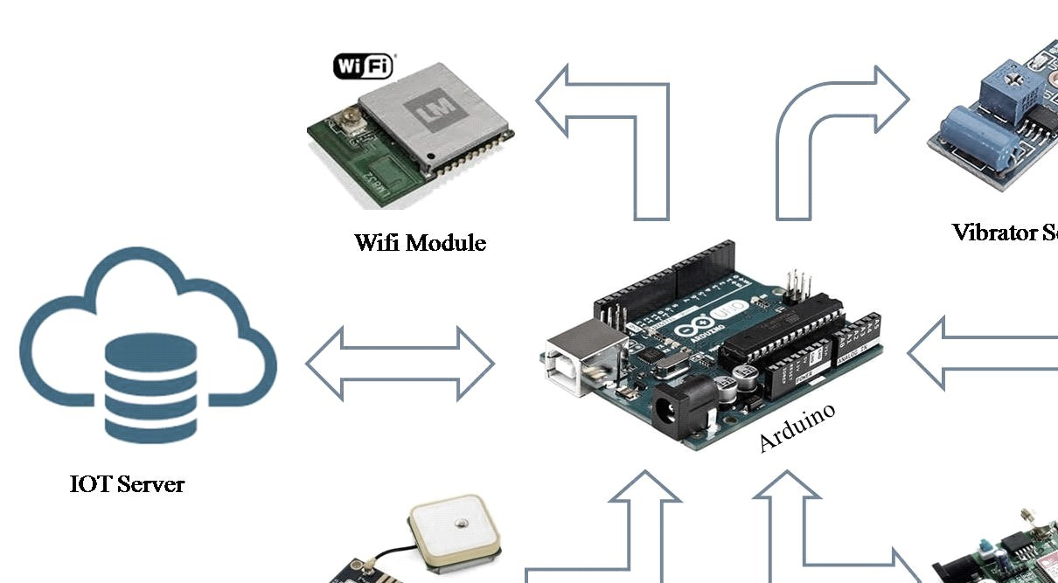

Fig 1: System Architecture

# SYSTEM SPECIFICATION

## HARDWARE REQUIREMENT

* Processor: Intel Core I3 or Higher
* RAM: 2GB or Higher
* HDD: 50GB (min)

## • Microcontroller: Arduino

* Device: Android Mobile
* WIFI Module
* GPS Module
* GSM Module
* Vibrator Sensor

## SOFTWARE REQUIREMENT

* OS: Microsoft Windows 7 or Above
* Programming Language: Android, JAVA, Embedded C
* Database: MySQL
* IDE: Net Beans, Android Studio, Arduino IDE

# PROJECT DESCRIPTION

## PROBLEM DEFINITION

As the range of urban vehicles is growing chop-chop vehicle thieving has become a crucial concern for all vehicle house owners. but gift anti-theft system lacks the pursuit and observance system. The vehicle anti-theft pursuit System supported internet of things is projected which might offer all spherical service to vehicle house owners.

## PROJECT OVERVIEW

The overview of this project is to develop a prototype which can track the location of vehicles using the GPS and ESP8266 WIFI module, with the help of smart phone.

## Advantage proposes

* The aim of victimisation IOT for pursuit and observance is thanks to the nice benefits that offer once operating with its elements.
* The desirable advantage of this technique is that it helps the owner in pursuit the vehicle at a bigger pace, and reduces the complexities compared to alternative systems, besides being a least expensive different for anti-theft system additionally.
* Compared to ancient anti-theft systems which needs customers to put in software system and track position of automotive on computers; this technique uses mechanical man phone as consumer terminal; therefore, simple to use and cheaper.
* The device uses free Google maps for pursuit the automotive.
* Client must pay just for knowledge web and SMS charges when initial setup.
* Doesn’t need maintenance.

# MODULE DESCRIPTION

## 1. Vehicle module

* Automatic On/Off
* Automatic Lock/Unlock
* Vehicle theft detection
* Update location
* Send Notification

## 2. IOT module

In this module, output is given to Arduino to send the message to the vehicle owner via IOT module.

* Vehicle location
* Vehicle ON/OFF by thief

## 3. Vehicle owner module

* Vehicle owner is present where all the activities are managed.
* Receive notification
* Send notification
* Check current location

# CONCLUSION AND FUTURE ENHANCEMENT

## CONCLUSION

In our project the protection system relies on embedded management that provides security against thieving. The GSM electronic equipment provides info to the user on his request. The owner will access the position of the vehicle at any instant. She/he sends a message so as to lock the vehicle. The GPS receiver on the kit can find the latitude and meridian of the vehicle victimisation the satellite service. This project deals with the look & development of a thieving system for vehicle additionally as defend the lifetime of rider.

## Scope for Future Development

With the assistance of high sensitivity vibration sensors, we will sight the accident. Whenever vehicle unexpectedly had associate accident on the road with facilitate of vibration detector, {we will/we are able to} sight the accident and that we can send the placement to the owner, hospital and police. we will extend the utilization of this technique to the automotive dispatching management field, that has huge potential for future development.

# REFERENCE

1. Rajatabh Agarwal, Boominathan P., “Vehicle Security System Using IOT Application”, International Research Journal of Engineering and Technology (IRJET), 2018.
2. Girish B. G., Akhilesh D Gowda, Hajira Amreen, Amit, K. M. Apoorva Singh, “IOT Based Security System For Smart Vehicle”, International Research Journal of Engineering and Technology (IRJET), 2018.
3. Mohammed F. Alrifaie, Norharyati Harum, Mohd Fairuz Iskandar Othman, Irda Roslan, Methaq Abdullah Shyaa, “Vehicle Detection and Tracking System IoT based: A Review”, International Research Journal of Engineering and Technology (IRJET), 2018.
4. N. Upendra Yadav, Prof. Kamalakannan, “Smart Vehicle Monitoring System using IOT”, IJDCST, MarchApril-2017.
5. H. V. Dadwani, R. B. Bukta, “Vehicle Tracking and Anti-Theft System Using Internet of Things”, International Journal of Advances in Electronics and Computer Science, 2017.
6. Patole Gitanjali H., Shinde Jyoti A., Salve Satish S., Prof. Vipul Ranjan Kaushik, Prof. Puri S. B., “IOT based Vehicle Tracking & Vehicular Emergency System- A Case Study and Review”, International Journal of Advanced Research in Electrical, Electronics and Instrumentation Engineering, 2017.